A Dendrochronological Analysis of The Miller House and Barn, Jericho Village, Northeast Ohio
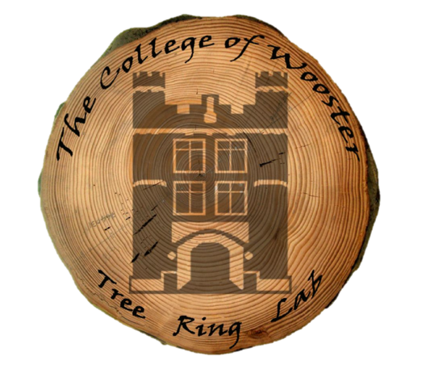
Juwan Shabazz, Kendra Devereux, Alexis Lanier,
Victoria Race, Greg Wiles, and Nick Wiesenberg
Tel: 330-263-2298, gwiles@wooster.edu

Wooster Tree Ring Lab
Department of Earth Sciences
The College of Wooster
Wooster, OH 44691
https://treering.voices.wooster.edu

Background and Objective:
On June 6th, 2018, we visited Lloyd and Jane Miller’s home and barn in Jericho village, to gather samples from their beams for research. The purpose of this final report is to show the results of the dendrochronological analysis of the Miller house and barn for Lloyd and Jane Miller. The Millers were interested in receiving a date for when their structures were built in hopes of better understanding the history of their home. Dendrochronology is the science of analyzing and dating annual growth rings in trees. This process can be used to assign calendar dates to timber felled for historical structures across Ohio.

Methods:
Six cores were taken from the Miller house, while seventeen were taken from the Miller barn (Figure 2), however only ten of the Miller barn cores were used as the other seven samples did not possess an outer ring or were in poor condition. The cores were extracted from hand hewn beams using incremental borers and then glued into mounts and sanded until the rings could be viewed clearly. Ring widths were measured at The College of Wooster’s Tree Ring lab to the nearest 0.001mm and with the aid of a program called COFECHA (Mayer, 2001), cross-dating of the cores was accomplished (Figure 1). A floating chronology was then created and compared to a calendar-dated northeast Ohio tree ring series to obtain calendar dates for the Miller house and barn.

Results and Analysis:
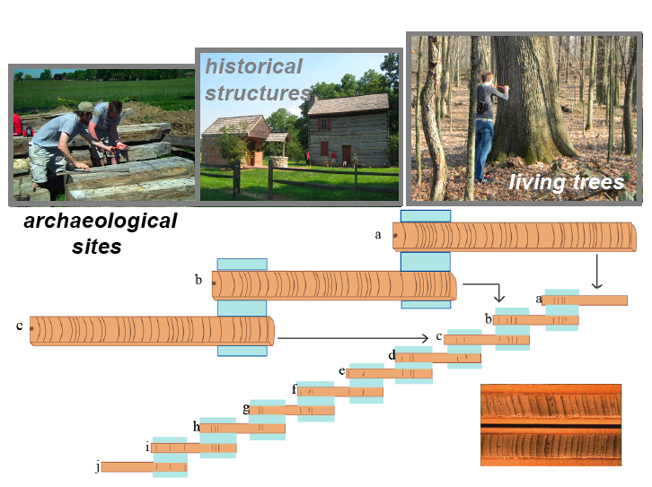
Results from this study can give us information regarding the year in which the timber used for the Miller’s structures was cut. The following table shows each sample and its years of growth. The total number of rings is recorded along with the first and last years of tree growth. The last ring represents the last year of each tree’s growth (Table 2).

Figure 1. Diagram illustrating tree ring cross-dating of a historic house or barn. Patterns of wide and narrow ring-widths from historic structures and wood associated with archaeological sites are matched to living tree ring chronologies and calendar dates are assigned to each ring.

Table 1. Results of the Miller house’s dendrochronological analysis.
Sample ID | Rings | First year | Last year | Additional notes
MILH01 | 131 | 1690 | 1821 | Full outer ring
MILH02W | 118 | 1703 | 1821 | Full outer ring
MILH03W | 188 | 1649 | 1837 | Full outer ring
MILH04W | 147 | 1672 | 1819 | Partial outer ring (Likely Standing Dead Tree)
MILH05E | 217 | 1632 | 1850 | Full outer ring
MILH06E | 168 | 1682 | 1850 | Full outer ring

Table 2. Results of the Miller barn’s dendrochronological analysis.
MILB01 | 156 | 1700 | 1856 | Partial outer ring
MILB04 | 166 | 1690 | 1856 | Full outer ring
MILB05 | 127 | 1729 | 1856 | Full outer ring
MILB06 | 116 | 1740 | 1856 | Partial outer ring
MILB07 | 173 | 1683 | 1856 | Full outer ring
MILB08 | 134 | 1706 | 1840 | Partial outer ring
MILB14 | 180 | 1676 | 1856 | Partial outer ring
MILB15 | 160 | 1696 | 1856 | Partial outer ring
MILB16 | 94 | 1762 | 1856 | Full outer ring
MILB18 | 132 | 1713 | 1845 | Partial outer ring

Miller House:
We have concluded that the wood used in the construction of Miller house was felled at two different time periods. The cores taken on the west side of the house indicate that the trees in the main part of the structure were most likely used for the assembly of the house in 1822, however, the east side of the house appears to have been built in 1851. This was determined by crossdating the ring-width data of the Miller house against the calendar-dated northeast Ohio tree ring series. The two different dates indicate that the Miller house was originally built in 1822, however was likely expanded upon with additional wood in 1851.

Miller Barn:
The dating from the Miller barn was a little more straightforward. The logs used in its construction appear to have been felled towards the end of the 1856 growing season, and thus likely used for assemblage in 1857. Eight of the ten sampled cores had an outer ring that dated back to 1856, this seems to indicate that the barn was felled during the end of the growing season of 1856, and then used for construction in 1857.

*
*
5.0mm

1848
1856

Figure 2. Photomicrograph of a core taken from the Miller barn. The image is taken from sample MILB01 and represents the time between 1848 and 1856 showing a complete outer ring that dates to 1856.

References:
Grissino-Mayer, H., 2001, Evaluating crossdating accuracy: A manual and tutorial for the computer program COFECHA: Tree-Ring Research, v. 57, p. 205-221.

