A Dendrochronological Analysis of The Zuercher House, Sonnenberg Village, Kidron Ohio
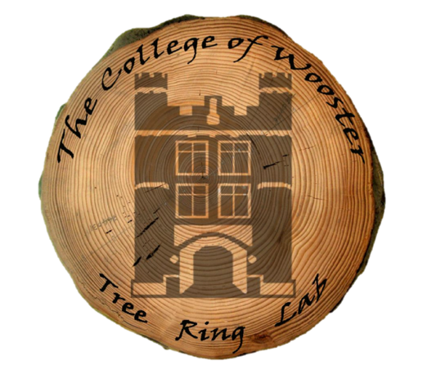
Kendra Devereux, Alexis Lanier, Juwan Shabazz,
Victoria Race, Greg Wiles, and Nick Wiesenberg
Tel: 330-263-2298, gwiles@wooster.edu

Wooster Tree Ring Lab
Department of Earth Sciences
The College of Wooster
Wooster, OH 44691
https://treering.voices.wooster.edu

Background and Objective:
On June 6^{th,} 2018, we visited the Sonnenberg Village project manager, Ray Leisy, at Old Lincoln Way East in Ohio. There we cored several beams from the Zuercher house that were being kept in various storage piles that will be used in the reconstruction of the Zuercher house, at Sonnenberg village later this year. The purpose of this final report is to show the results of the dendrochronological analysis of the Zuercher house for Ray Leisy. Dendrochronology is the science of analyzing and dating annual growth rings in trees. This process can be used to assign calendar dates to timber felled for historical structures across Ohio.

Methods:
Twelve cores were collected from the beams, and all were identified as white oak. Seven of these cores possessed outer rings and were used in dating the house because in order to properly date a structure, an outer ring must be present. The outer ring reveals the last year of growth for a tree; felled timber typically is used for construction soon after it has been cut from the forest, and so by using the last year of growth as a reference point, dendrochronologists can decipher when structures were built. Ring widths of these seven cores were measured back at the College of Wooster to the nearest 0.001mm and we used a computer program called COFECHA (Mayer, 2001), to aid in cross-dating the cores with one another (Figure 1) to develop a “floating ring-width chronology”. The floating ring width chronology was then compared to a master file comprised of hundreds of calendar-dated samples from northeast Ohio to determine a calendar date for the series.

Results and Analysis:
Results from this study can give us information regarding the likely year that this house was constructed. Table 1 shows each sample and its identified years of growth indicating the total number of rings for each sample along with the first and last years of tree growth.
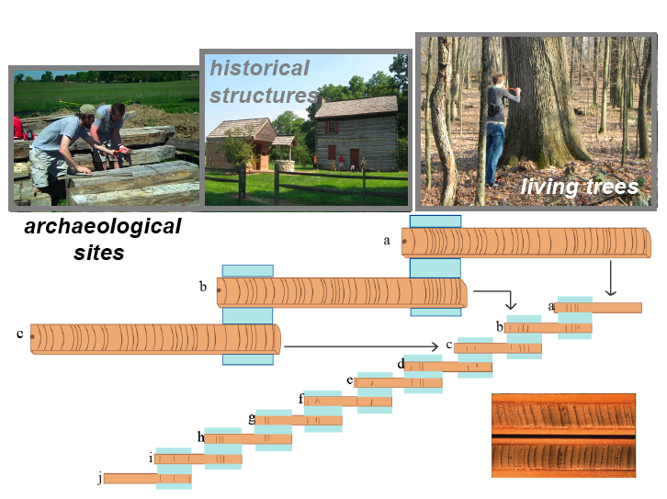

Figure 1. Diagram illustrating tree ring cross-dating of a historic house or barn. Patterns of wide and narrow ring-widths from historic structures and wood associated with archaeological sites are matched to living tree ring chronologies and calendar dates are assigned to each ring.

Table 1. Results of the dendrochronological analysis.
Sample ID | Rings | First year | Last year | Additional notes
ZH03 | 113 | 1719 | 1832 | Partial outer ring
ZH05 | 109 | 1726 | 1835 | Partial outer ring
ZH06 | 129 | 1714 | 1843 | Partial outer ring
ZH07 | 117 | 1713 | 1830 | Full outer ring
ZH08 | 108 | 1720 | 1833 | Full outer ring
ZH09 | 118 | 1715 | 1833 | Partial outer ring
ZH11 | 105 | 1726 | 1831 | Full outer ring

We have concluded that the logs were felled after the growing season of 1830, and before the growing season of 1835, at the latest (Table 1). Several of the sampled cores were missing outer rings due to factors such as insect activity. As mentioned previously, outer rigs possess the last year of growth for trees, and so without them, it becomes difficult to use cores in dating structures. There were also a few anomalies worth mentioning as well, in particular, sample ZH06. This beam of later date was likely added in after the original structure was built. Unfortunately, the building had been disassembled before sampling, so we were unable to evaluate the cores that would have suggested this later addition. Nonetheless, many of the final dates fall within the earlier half of the 1830’s. For this reason, it is most likely that the Zuercher house was constructed in 1833 (Table 1; Figure 2).

1823
*
5.0mm
*
1832
Figure 2: Photomicrograph of sample ZH03, a core taken from the Zuercher house. The three dots on the right side of the image are used every 100 years, while two dots are used every 50 years. The sample image represents the years 1823 to 1832.

References:
Grissino-Mayer, H., 2001, Evaluating crossdating accuracy: A manual and tutorial for the computer program COFECHA: Tree-Ring Research, v. 57, p. 205-221.

